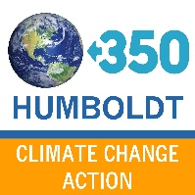
I took the Climate Pledge, and these are my priorities:
- Transition transportation systems from fossil fuels by 2045.
- Incentivize infill development and discourage greenfield conversion.
- Decarbonize new and existing buildings by 2045.
- Transition from fossil fuels in electricity generation by 2025. Invest in renewable, locally-produced energy.
- Guarantee Green Jobs for all.

